**Capstone Project - The Battle of Neighborhoods**

**Report**

**Shay Ben Yehuda**

**About the project**

The goal of this project is to help people explore better facilities around them. This will help people make a smart and effective decision in choosing a great neighborhood from several other neighborhoods in Scarborough, Toronto.

Many people migrate to Canada and need a lot of research on good housing prices and venues in Scarborough.

The goal of this project is to create an analysis of features for people migrating to Scarborough and find the best neighborhood for them.

**The Problem**

The main goal of this project is to help people who want to migrate to Scarborough to learn about the neighborhoods in the borough and find the most suitable one for them (considering the venues and house prices).

**About the location**

Scarborough is an administrative division of Toronto, Ontario, Canada. Situated atop the Scarborough Bluffs, it occupies the eastern part of the city. Scarborough is contained within the borders of Victoria Park Avenue on the west, Steeles Avenue to the north, Rouge River and the city of Pickering to the east, and Lake Ontario to the south. It borders Old Toronto, East York and North York in the west and the city of Markham in the north. Scarborough was named after the English town of Scarborough, North Yorkshire.

First settled by Europeans in the 1790s, Scarborough has grown from a collection of small rural villages and farms to become fully urbanized with a diverse cultural community. Incorporated in 1850 as a township, Scarborough became part of Metropolitan Toronto in 1953 and was reconstituted as a borough in 1967. Scarborough rapidly developed as a suburb of Toronto over the next decade and became a city in 1983. In 1998, Scarborough and the rest of Metropolitan Toronto were amalgamated into the present city of Toronto. Scarborough still exists in name and as a borough of Toronto. The Scarborough Civic Centre, the former city‘s last place of government, is occupied by City of Toronto government offices.

Scarborough is a popular destination for new immigrants in Canada to reside. As a result, it is one of the most diverse and multicultural areas in the Greater Toronto Area, being home to various religious groups and places of worship. It includes a number of natural landmarks, including the Toronto Zoo, Rouge Park and the Scarborough Bluffs. The northeast corner of Scarborough is largely rural with some of Toronto’s last remaining farms, earning Scarborough its reputation of being greener than any other part of Toronto.

**The Data**

We will use the data set we retrieved from Wikipedia in week 3. The data set contains latitude and longitude, and zip codes.

We will need data about different venues in different neighborhoods of that specific borough. In order to gain that information we will use "Foursquare" locational information. Foursquare is a location data provider with information about all manner of venues and events within an area of interest. Such information includes venue names, locations, menus and even photos. As such, the foursquare location platform will be used as the sole data source since all the stated required information can be obtained through the API.

After finding the list of neighborhoods, we then connect to the Foursquare API to gather information about venues inside each neighborhood. For each neighborhood, we have chosen the radius to be 100 meter.

The data retrieved from Foursquare contained information of venues within a specified distance of the longitude and latitude of the postcodes. The information obtained per venue as follows:

1. Neighborhood
2. Neighborhood Latitude
3. Neighborhood Longitude
4. Venue
5. Name of the venue e.g. the name of a store or restaurant
6. Venue Latitude
7. Venue Longitude
8. Venue Category

**Methodology**

To compare the similarities of the neighborhoods, we need to segment them, and group them into clusters.

Clustering Approach

To compare the similarities of two cities, we decided to explore neighborhoods, segment them, and group them into clusters to find similar neighborhoods in a big city like New York and Toronto. To be able to do that, we need to cluster data which is a form of unsupervised machine learning: k-means clustering algorithm.

Foursquare API

This project would use Four-square API as its prime data gathering source as it has a database of millions of places, especially their places API which provides the ability to perform location search, location sharing and details about a business.

Using credentials of Foursquare API features of near-by places of the neighborhoods would be mined. Due to http request limitations the number of places per neighborhood parameter would reasonably be set to 100 and the radius parameter would be set to 500.

**Results**

The top venues in each neighborhood are described in the table below:

|  |  |  |  |  |  |  |  |  |  |  |  |  |
| --- | --- | --- | --- | --- | --- | --- | --- | --- | --- | --- | --- | --- |
| **Neighborhood** | **Cluster Labels** | **1st Most Common Venue** | **2nd Most Common Venue** | **3rd Most Common Venue** | **4th Most Common Venue** | **5th Most Common Venue** | **6th Most Common Venue** | **7th Most Common Venue** | **8th Most Common Venue** | **9th Most Common Venue** | **10th Most Common Venue** | **Average Price** |
| Malvern, Rouge | 2 | Home Service | Construction & Landscaping | Train Station | College Stadium | Golf Course | Gift Shop | General Entertainment | Fried Chicken Joint | Fast Food Restaurant | Electronics Store | 426,850 |
| Rouge Hill, Port Union, Highland Creek | 2 | Home Service | Bar | Train Station | College Stadium | Golf Course | Gift Shop | General Entertainment | Fried Chicken Joint | Fast Food Restaurant | Electronics Store | 444,309 |
| Guildwood, Morningside, West Hill | 0 | Gym / Fitness Center | Construction & Landscaping | Park | College Stadium | Golf Course | Gift Shop | General Entertainment | Fried Chicken Joint | Fast Food Restaurant | Electronics Store | 316,584 |
| Woburn | 0 | Coffee Shop | Korean Restaurant | Business Service | Park | College Stadium | Gift Shop | General Entertainment | Fried Chicken Joint | Fast Food Restaurant | Electronics Store | 289,646 |
| Cedarbrae | 0 | Trail | Playground | Coffee Shop | Golf Course | Gift Shop | General Entertainment | Fried Chicken Joint | Fast Food Restaurant | Electronics Store | Discount Store | 356,096 |
| Scarborough Village | 0 | Ice Cream Shop | Train Station | Restaurant | Coffee Shop | Gift Shop | General Entertainment | Fried Chicken Joint | Fast Food Restaurant | Electronics Store | Discount Store | 293,600 |
| Kennedy Park, Ionview, East Birchmount Park | 0 | Coffee Shop | Hobby Shop | Bus Line | Light Rail Station | Discount Store | Department Store | Convenience Store | College Stadium | Gift Shop | General Entertainment | 347,446 |
| Golden Mile, Clairlea, Oakridge | 0 | Bus Line | Bakery | Coffee Shop | Intersection | Metro Station | Bus Station | Gym | Soccer Field | Breakfast Spot | Convenience Store | 542,218 |
| Cliffside, Cliffcrest, Scarborough Village West | 0 | Ice Cream Shop | Coffee Shop | Pharmacy | Pizza Place | Restaurant | Sandwich Place | Liquor Store | Discount Store | Hardware Store | Department Store | 522,905 |
| Birch Cliff, Cliffside West | 0 | College Stadium | General Entertainment | Skating Rink | Café | Gym | Train Station | Golf Course | Gift Shop | Fried Chicken Joint | Fast Food Restaurant | 279,189 |
| Dorset Park, Wexford Heights, Scarborough Town... | 0 | Bakery | Gift Shop | Train Station | College Stadium | Golf Course | General Entertainment | Fried Chicken Joint | Fast Food Restaurant | Electronics Store | Discount Store | 422,689 |
| Wexford, Maryvale | 0 | Auto Garage | Convenience Store | Gym | Golf Course | Gift Shop | General Entertainment | Fried Chicken Joint | Fast Food Restaurant | Electronics Store | Discount Store | 332,710 |
| Agincourt | 0 | Shopping Mall | Discount Store | Badminton Court | Park | Sushi Restaurant | Supermarket | Pool | Construction & Landscaping | Convenience Store | Department Store | 411,143 |
| Clarks Corners, Tam O'Shanter, Sullivan | 0 | Fast Food Restaurant | Pharmacy | Coffee Shop | Golf Course | Pizza Place | Bus Stop | Shopping Mall | Fried Chicken Joint | Thai Restaurant | Chinese Restaurant | 375,307 |
| Milliken, Agincourt North, Steeles East, L'Amo... | 1 | Pharmacy | Train Station | Golf Course | Gift Shop | General Entertainment | Fried Chicken Joint | Fast Food Restaurant | Electronics Store | Discount Store | Department Store | 440,688 |
| Steeles West, L'Amoreaux West | 0 | Fast Food Restaurant | Pharmacy | Sandwich Place | Electronics Store | Discount Store | Coffee Shop | Chinese Restaurant | Other Great Outdoors | Pizza Place | Grocery Store | 529,278 |

And the map:

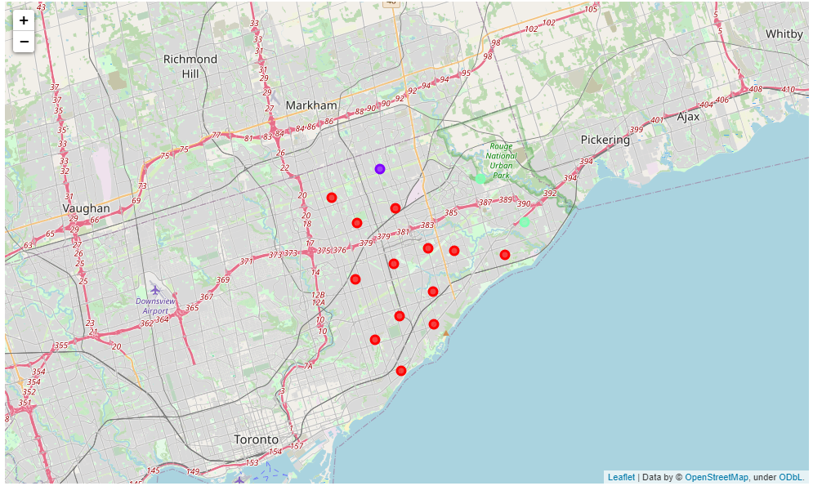

The Average Price in each cluster:

|  |  |
| --- | --- |
| **Cluster Labels** | **Avg** |
| **0** | 386,062 |
| **1** | 440,688 |
| **2** | 435,580 |

**Discussion**

Considering the results, I think anyone who intends to move to Scarborough should think about what venues interest him and are important to him. He will then be able to check by proximity to attractions and by average price in the area, thus making it easier for him to focus his search for an apartment.

Everyone will make their own weighting of location and amount of money that he is willing to invest in the house.

**Conclusion**

In this report we have shown a breakdown of neighborhoods in Scarborough according to nearby venues and shown a way to help choose a home.

I feel like I learned a lot while working on this project.